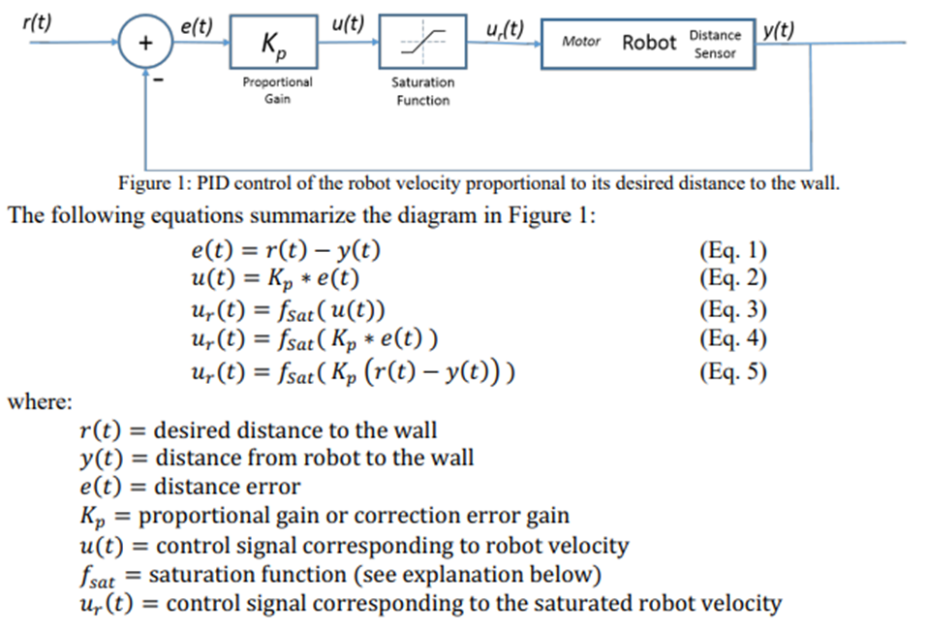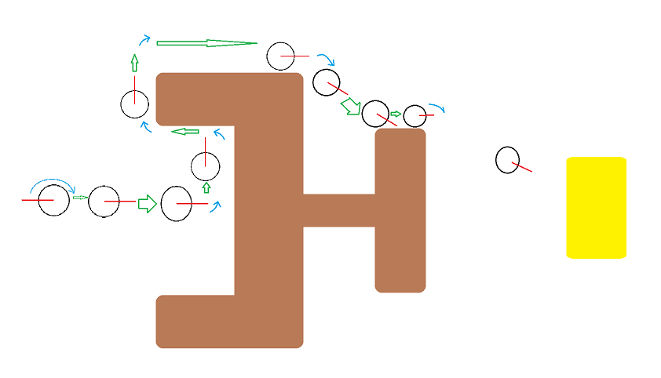

I used the PID control to set the speed of the motors to prevent it from hitting most of the walls.

For the vision based movement I used the camera width / 2 to find the center of the camera, to center an object I had the robot turn left or right respectively until the object’s position on image would equal the camera width / 2. If the camera did not observe an object it would rotate until one is spotted before centering. If it is centered then the robot moves forward. For wall following I used the same PID control as lab 3 for different kp weights for forward movement and side following movement.

Task 2 States Explanation

For task 2 of this lab I had 4 possible states the robot could be in, the starting state of state 0 is for when the robot is supposed to see the goal but it is not currently and to rotate the robot until the cylinder is spotted. Once the cylinder is spotted the state becomes state 1 where the robot centers onto the goal. When the goal is centered on the camera it is now in state 2. State 2 is motion towards the goal where the robot continues forward using the PID control to a specified distance away from the robot. If an obstacle is detected in the way of the forward movement then the robot enters into state 3 of the wall following. The robot follows the wall with checks for special cases of corners where the robot will turn at a 90 degree angle before continuing its wall following. If the robot is able to see the goal and the robot is not hitting a wall to its side and there is no obstacle then the conditions are met to go from state 3 into state 1, where the robot centers on the goal and then state 2 moves it to the finish.

Conclusion Thing

The code could be improved by having a better rotation to make it stick to a closer + looking axis so if it is not close than to rotate to fit in a better grid pattern. The robot goes really close to the wall at a specific segment and I spent a lot of time trying to fix it and at this point I don’t think it's worth more time and effort just to gain another five percent on the lab. I already gave it a lot of time and I believe it’s okay to move on as the mental strain of this project has taken on me. I enjoy playing around with the code to find when it breaks and what is causing it and how to fix it. There were lots of issues encountered for the motion planning of this lab. I painted the movement in MS Paint to plan it out.